JNTUA College of Engineering (Autonomous) Ananthapuramu-515002 (A.P) INDIA
TEQIP-III Sponsored One-Week FDP on “Reinforcing Professional Communication Skills for Teaching Faculty” conducted by the Department of Humanities from 11-06-2018 to 15-06-2018
REPORT
The Department of Humanities and Social Sciences, JNTUA College of Engineering, Ananthapuramu, organized a One-Week Faculty Development Programme on “Reinforcing Professional Communication Skills for the Teaching Faculty” from 11-06-2018 to 15-06-2018 on the college premises. The FDP aims to reinvigorate passion for teaching among teaching fraternity and aligning the pedagogical tools to serving the learner centric classroom by updating the communicative paraphernalia of the faculty with recent development in teaching. About 130 participants from different parts of the country had participated in this program.
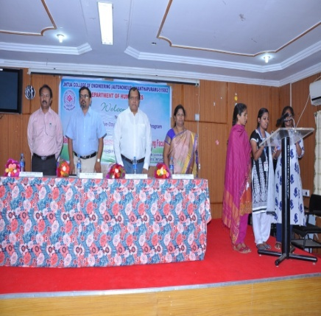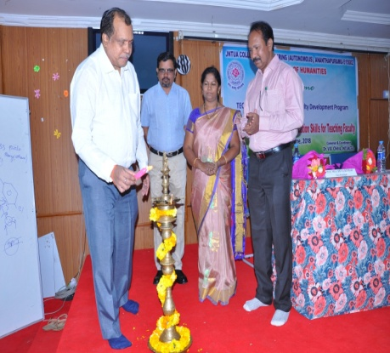
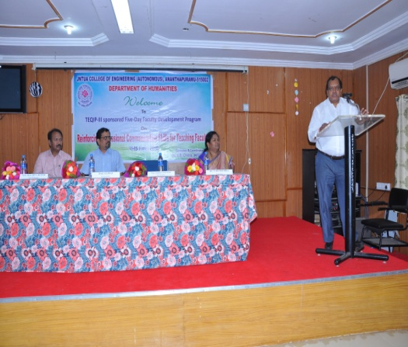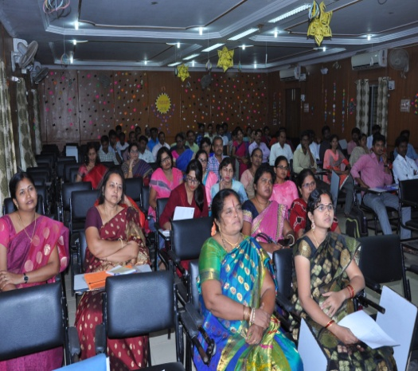
The program started with the registration at 8:30am on 11th June followed by the inaugural function. Hon’ble Vice Chancellor Prof. S. Srinivas Kumar lighted the lamp marking the inauguration of One-Week FDP.

Prof. M. L. S. Deva Kumar, Vice Principal of the college had presided over the function. The Coordinator of the program, Dr. V.B.Chithra welcomed the guests and participants. She has detailed about the courses offered by the department of Humanities. Further, she has highlighted the objectives of the FDP with an emphasis on reinforcing the communication skills for teachers for effective instructional delivery system.
In his address, Prof. M. L. S Deva Kumar emphasized the significance of the FDP and importance of communication skills for the professionals.

Hon’ble VC Prof. S. Srinivas Kumar in his inaugural speech stated the responsibilities of a teacher and advised them to update their teaching skills and also stressed the need of the teachers to become life-long learners.

Key Note Address was presented by the Resource Person Prof. S. Jaya Raju Garu, Department of Phonetics and Spoken English, EFLU, Hyderabad. In his speech he briefly introduced the proposed topics/themes to be discussed in the Program.

Director of Foreign Affairs, Prof. K.B.Chandra Sekhar, Director of Faculty Development Centre, Prof.G.Prasanthi, Prof.K.Hemachandra Reddy, Prof.R.Padma Suvarna, Prof. S.Vasundra Prof.R.Bhuvana Vijaya, Dr.T.Narayana Reddy, Prof.E.Aruna Kanthi, Ms.S.Sarada, Dr.P.Dinesh Sankar Reddy, Dr.A.P.Siva Kumar, Dr.D.Vishnu Vardhan, Dr.K.Jayalakshmi, Dr.Saila Kumari and other faculty members of the department graced the inaugural function.

The first two sessions were handled by Prof.S.Jaya Raj. In his lecture, Prof.Jaya Raj insisted on the varieties of Englishes and need for the neutralization of accent in the present global era. He has thrown light on the concepts such as English-Englishes, non-native apprehensions, standardization, comprehensibility, linguistic approximation etc.
Eminent teachers from reputed universities like EFLU, BITS Pilani served as resource persons for the five-day programme. Prof. V .V. N. Rajendra Prasad, Prof. B. R. Megha Raj, Prof. G. Suvarna Lakshmi, Prof. M. G. Prasuna, Prof. V. Sankar, Dr. R. V. Jayanth, Dr.M.Sambaiah etc were resourceful in providing the inputs for the thrust areas like, Independent Language Learning, Trends in Teaching & Research, Socio-Linguistics, Language in Use(Pragmatics), Testing and Evaluation Methods, Classroom Management, Academic Writing, Interpersonal Skills, Teaching Materials, Technology-enabled Learning and Outcome-Based Education .

The Five-Day programme came to an end on 15-06-2018 with valedictory function followed by feedback by the participants. They expressed their immense pleasure in conducting a program like this which genuinely reinforced their communicational skills.
The Rector of the University Prof.K.Prahlada Rao served as the Chief Guest and reinstated the importance of the program and congratulated the organizing team for making this programme a memorable one.

Vice Principal Prof.M.L.S.Deva Kumar and the Convenor of the Program Dr.V.B.Chithra expressed their gratitude towards everyone for making the program a grand success. Prof.K.Prahlada Rao distributed the participation certificates to the delegates and finally the program was ended with the national anthem.
