JNTUA College of Engineering (Autonomous) Ananthapuramu-515002 (A.P) INDIA
TEQIP-III Sponsored One-Week FDP on “Soft Skills and Personality Development” conducted by the Department of Humanities from 10-12-2018 to 14-12-2018
REPORT
The Department of Humanities and Social Sciences, JNTUA College of Engineering, Ananthapuramu, organized a One-Week Faculty Development Programme on “Soft Skills and Personality Development” from 10-12-2018 to 14-12-2018 on the college premises. The FDP focuses on creating a lively interest in soft skills and personality development for the career development and professional satisfaction of teachers. About 160 participants from different parts of the country have participated in this program.
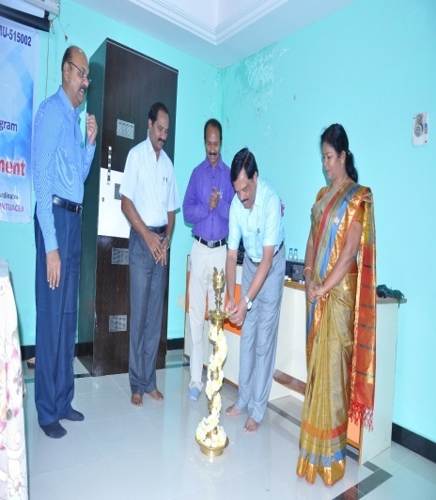
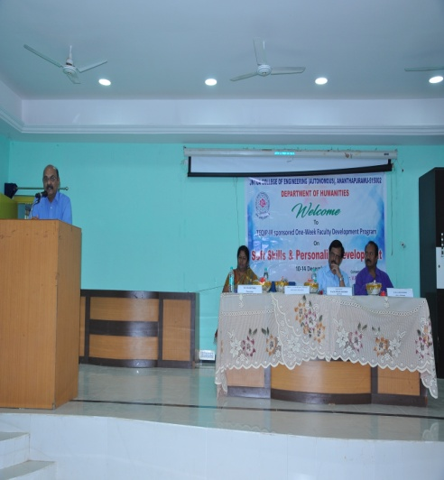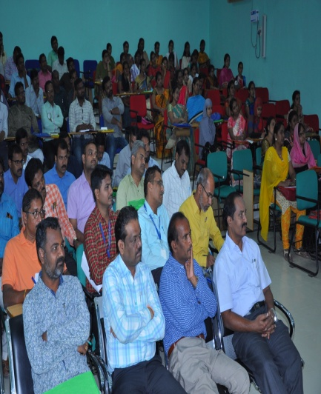

The program started with the registration at 8:30am on 10thDecfollowed by the inaugural function. Rector of JNTU, Prof. K. Prahlada Rao, and Prof S.Krishnaiah, Registrar of the University lighted the lamp marking the inauguration of One-Week FDP.

Prof.M.L.S Deva Kumar, Vice Principal of the college presided over the function. The Coordinator of the program, Dr. V.B.Chithra welcomed the guests and participants. She has detailed about the courses offered by the department of Humanities. Further, she has highlighted the objectives of the FDP with an emphasis on reinforcing the soft skills for teachers for effective instructional delivery system .In his address, Prof.M.L.SDeva Kumar emphasized the significance of the FDP and importance of soft skills for the professionals.

Prof. K.Prahlada Rao, in his inaugural speech stated the responsibilities of a teacher and advised them to update their teaching skills and also stressed the need of the teachers to become life-long learners.

Key Note Address was presented by the Resource Person Prof. V.V.N. Rajendra Prasad Garu, Visiting Professor of English from AP Central University, Anantapur. In his speech he briefly introduced the proposed topics/themes to be discussed in the Program.

Professors of the College and other faculty members of all the departments graced the inaugural function.

The first two sessions were handled by Prof. V.V.N.Rajendra Prasad. In his lecture, he threw light on the areas of verbal & non-verbal communication and their significance in soft skills. He discussed the various types of communication in an elaborate and illustrative manner.

Eminent teachers from reputed universities and Soft Skills Trainers from various places served as resource persons for the five-day programme. Prof. V.V.N.Rajendra Prasad, Prof. Ch.Rajendra Prasad, Prof. S.M. Basha, Dr. B.Suseela, Mr.V.V.R.K.Sastry, Prof. K.Venugopal, Prof. V.Sankar, Prof.K.Prahlada Rao, Prof.K,Hemachandra Reddy, Prof.P.R.Bhanumurthi and Dr.M.Sambaiah etc were resourceful in providing the inputs for the thrust areas like, Non-Verbal Communication & Soft Skills, Teaching & Learning as an act of communication, Quality Concerns in Higher Education, Stress Management, Emotional Intelligence, Leadership and Communication, Professional Ethics, Competencies and Skills for 2020, Leadership and Team Building. Perception and Creative Thinking, Time Management and Decision Making Skills.

The Five-Day programme came to an end on 14-12-2018 with valedictory function followed by feedback by the participants. They expressed their immense pleasure in conducting a program like this which genuinely reinforced their soft skills.
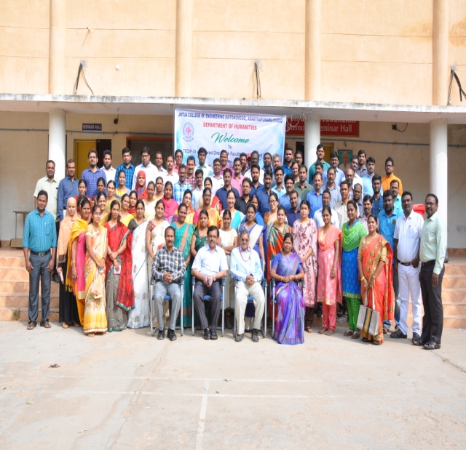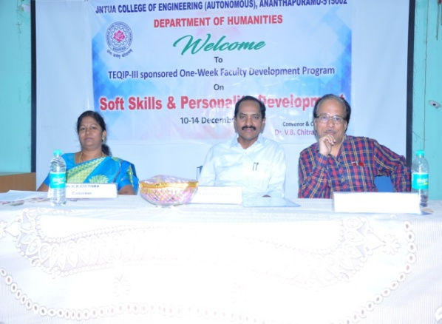

The Registrar of the University, Prof. S.Krishnaiah served as the Chief Guest and reinstated the importance of the program and congratulated the organizing team for making this programme a memorable one.

Prof. P.R.Bhanumurthi served as the Presiding officer and the Convenor of the Program Dr.V.B.Chithra expressed her gratitude towards everyone for making the program a grand success. Prof..S.Krishnaiah distributed the participation certificates to the delegates and finally the program was ended with the national anthem.
